Dear Fellow CCDU Members and Supporters,

Please join us on the evening of Wednesday, August 9, 2023 at 7:00 p.m. for our monthly meeting!

Agenda:

1. Call to Order and Opening Remarks from President Eric Rudin;
2. Approval of Minutes from July 12, 2023 CCDU Meeting;
3. Report from Treasurer Judy Scott;
4. Special Guest Speakers

* Congressmember Angie Craig (D-MN)
* Former CCUSD School Board Member, Summer McBride
5. Announcements;
6. Items From the Floor;
7. Adjournment.

Zoom link: https://us06web.zoom.us/j/86858894560?pwd=SmZhd3MzRlJ2cGJ2aHFESldSNkxXZz09
Meeting ID: 868 5889 4560
Passcode: 626064

I look forward to seeing you all at our Club’s next meeting!

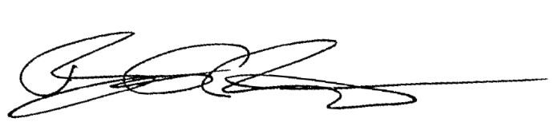
Best regards,

Eric Rudin
Culver City Democrats Untied President

