Dear Fellow CCDU Members and Supporters,

Please join us on the evening of Wednesday, January 10, 2024 at 7:00 p.m. for our monthly meeting! Below is our Agenda:
1. Call to Order and Opening Remarks from President Eric Rudin;
2. Approval of Minutes from December 13, 2023 CCDU Meeting;
3. Report from Treasurer Judy Scott;
3. Report from VP of Membership Ron Ostrin;
5. Special Guest Speakers
* Congresswoman Sydney Kamlager-Dove (D-CA);
* Assemblyman Isaac Bryan (D-CA);
6. Consent Calendar – March 2024 Primary Endorsements
Recommended by CCDU Executive Board:
6a. County Supervisor, 2nd District: Holly Mitchell (D-Incumbent)
6b. Assembly Member 55th District: Isaac Bryan (D-Incumbent)
Procedure: Motion to Approve Consent Calendar. Requires 60% of Members Present Voting in Affirmative;
7. Endorsements for Judicial Races;
8. Consideration of Culver City Measure E;
9. Items from the Floor;
10. Adjournment.

I look forward to seeing you all at our Club’s next meeting!
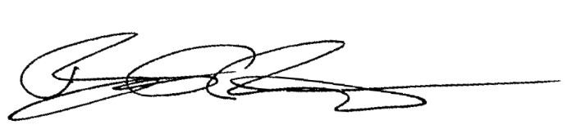
Best regards,

Eric Rudin
Culver City Democrats Untied President

