Dear Fellow CCDU Members and Supporters,

Please join us on the evening of Wednesday, April 10 at 7:00 p.m. for our monthly meeting! Below is our Agenda:

- Call to Order and Opening Remarks from President Eric Rudin;
- Approval of Minutes from March 13, 2024 CCDU Meeting;
- Report from Treasurer Judy Scott;
- Report from VP of Membership Ron Ostrin;
- Special Guests: Ray Long, President, Culver City Federation of Teachers; Debbie Hamme, President, Association of Classified Employees
- Items from the Floor;
- Adjournment.

I look forward to seeing you all at our Club’s next meeting!

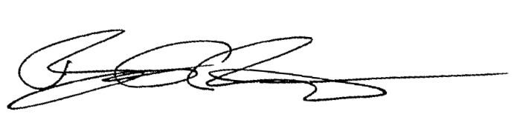
Best regards,

Eric Rudin
Culver City Democrats United President

