Dear Fellow CCDU Members and Supporters,

Please join us Wednesday, June 12, 2024, at 7:00 p.m. for our monthly meeting! Below is our Agenda:

- Call to Order and Opening Remarks from President Eric Rudin;
- Approval of Minutes from April 10, 2024 CCDU Meeting;
- Report from Treasurer Judy Scott;
- Report from VP of Membership Ron Ostrin;
- Special Guest: Los Angeles County Supervisor, Lindsey Horvath;
- Announcements;
- Items from the Floor;
- Adjournment.

I look forward to seeing you all at our Club’s next meeting!

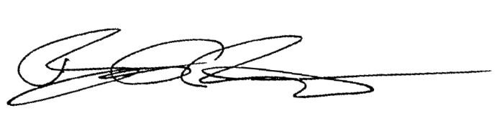
Best regards,

Eric Rudin
Culver City Democrats United President

