Dear Fellow CCDU Members and Supporters,

Please join us tomorrow, the evening of Wednesday, December 11, 2024 at 7:00 p.m. for our monthly meeting! Below is our Agenda:

- Call to Order and Opening Remarks from President Eric Rudin;
- Approval of Minutes from November 13, 2024 CCDU Meeting;
- Report from Treasurer Judy Scott;
- Report from VP of Membership Ron Ostrin;
- CCDU Executive Board Member Election;*
- Announcements;
- Items from the Floor;
- Adjournment.

*CCDU Executive Board Member Election (Part 1)

The current Executive Board has endorsed the following qualifying members for the following positions:
- President – Darrel Menthe
- Treasurer – Judy Scott
- Secretary – Jamie Wallace
- VP of Communications – Eli Jones

PLEASE NOTE THAT ONLY QUALIFYING MEMBERS PRESENT AT THIS MONTH’S DECEMBER 11, 2024 MEETING AT 7PM ARE ELIGIBLE TO VOTE ON THE ABOVE BOARD POSITIONS. THE ADDITIONAL BOARD POSITIONS WILL BE ON NEXT MONTH’S AGENDA.

I look forward to seeing you all at our Club’s next meeting!

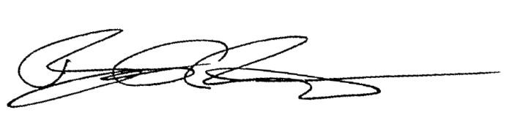
Best regards,

Eric Rudin
Culver City Democrats United President

